**DOCUMENTATION MODEL BUILD**

EXPERIMENT #1 17/08/2022

First parameter setting with ensemble s-curve observed

N = 10

index_for_choice = 20 (this is the number of countries, that are taken by every individual country into account)

CountryModel(0.015, 0.12)

Base_alert = 0.015% (this is similar to broadcasting influence in typical bass diffusion model)

Social_alert_threshold = 0.12

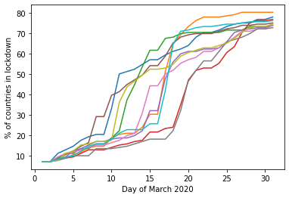

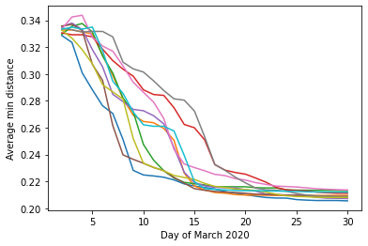

N= 100

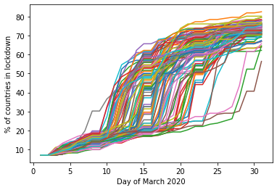

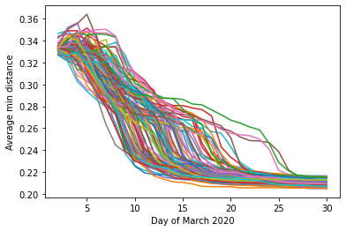

First parameter setting with ensemble s-curve observed

N = 10

Clique_size = 15 (this is the number of countries, that are taken by every individual country into account)

Base_alert = 0.015 (this is similar to broadcasting influence in typical bass diffusion model)

Social_alert_threshold = 0.12 (this is the threshold that needs to be passed (from below) so that a country adopts lockdown based on social influence)

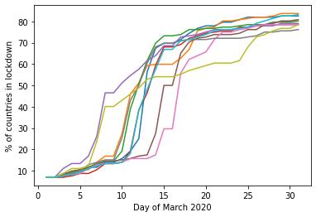

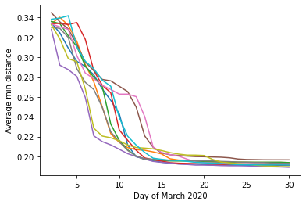

EXPERIMENT #2 18/08/2022

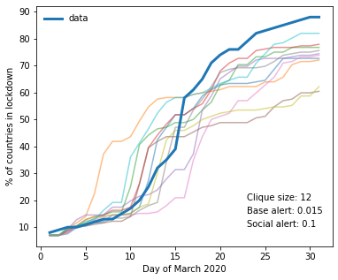

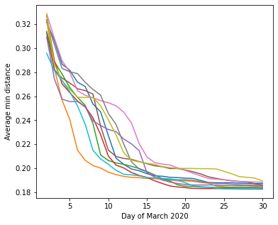

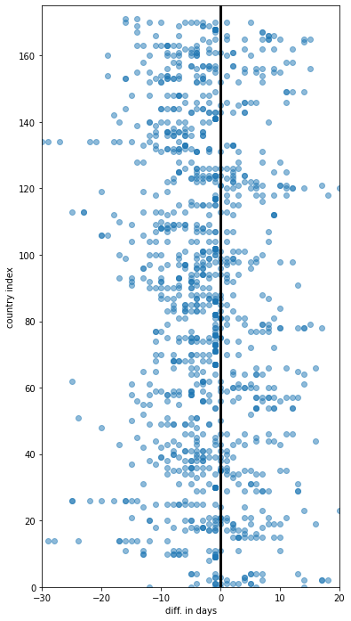

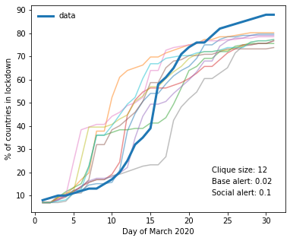

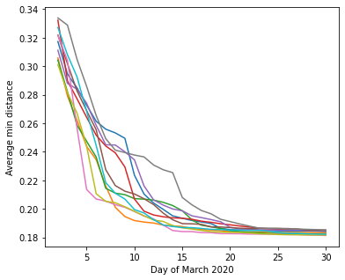

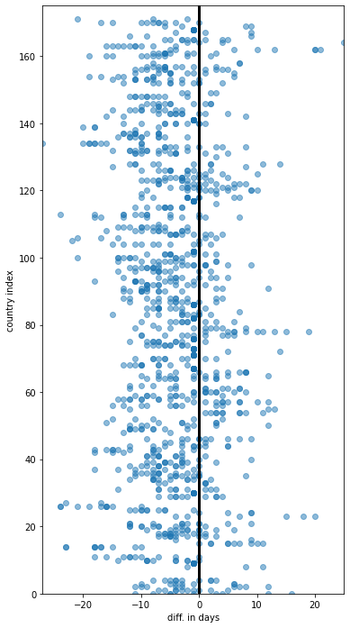

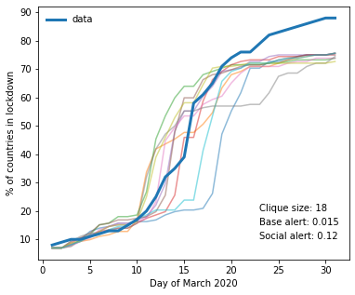

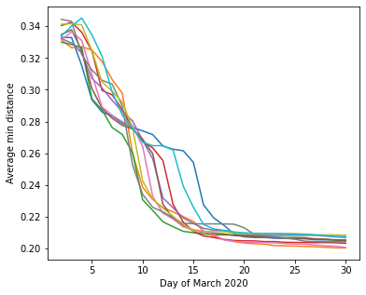

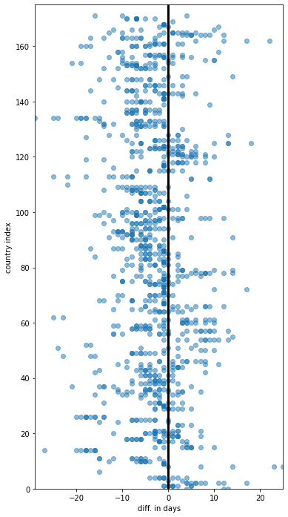

EXPERIMENT #3 18/08/2022

The rule to set the base alert threshold includes now both pop density as well as a weight by democracy

a.alert_adoption_threshold = (agent_data["log_population_density_normalized_on_average"][i])**2 * (1/agent_data["democracy_index_normalized_on_average"][i]) * base_alert

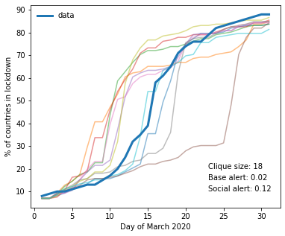

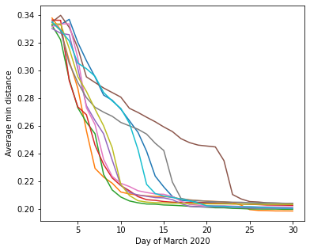

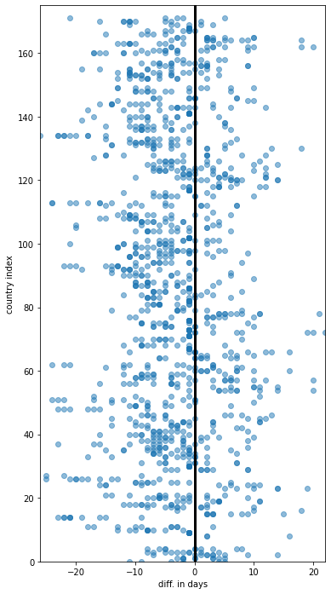

a.alert_adoption_threshold = (agent_data["log_population_density_normalized_on_average"][i])**2 * np.sqrt(1/agent_data["democracy_index_normalized_on_average"][i]) * base_alert

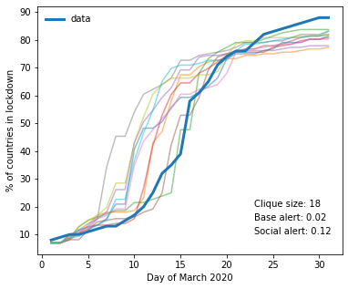

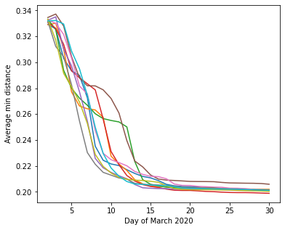

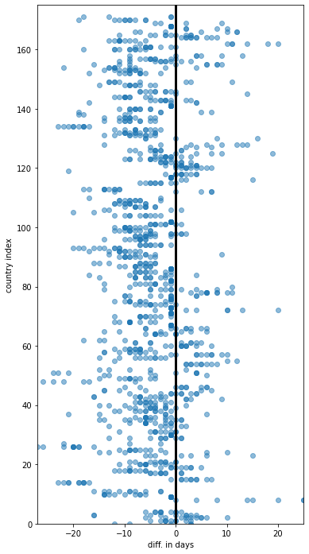

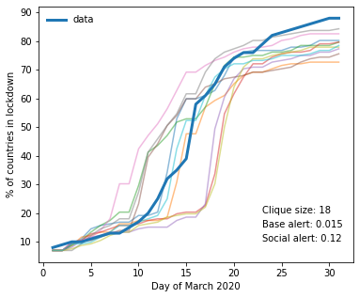

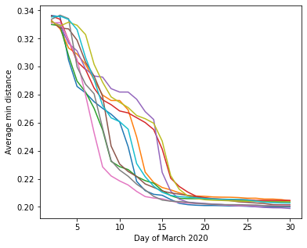

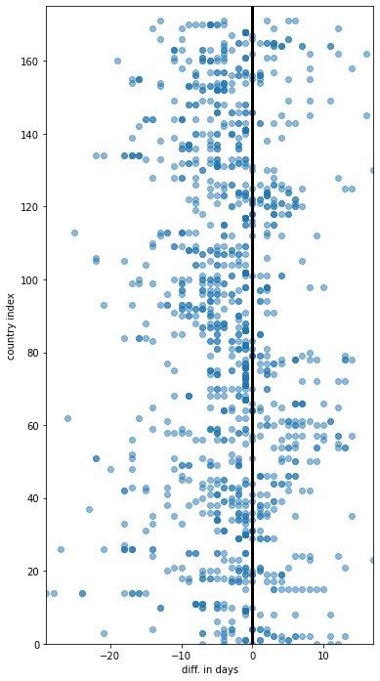

Same as one above but for N = 100

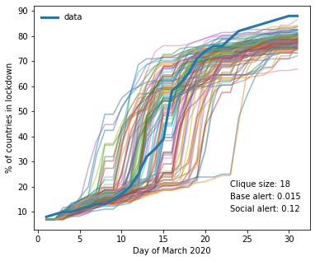

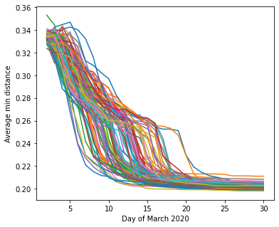

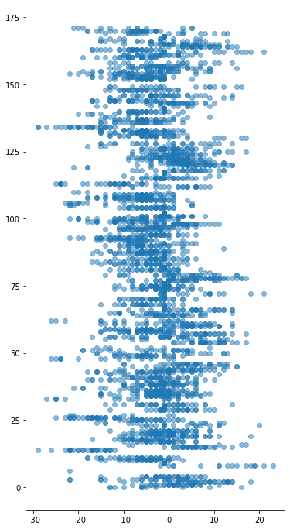

EXPERIMENT #4 18/08/2022

New rule implement square root now influence of democracy on social base threshold. To give autocracies more social reaction affinity. (which as seen below delays lockdowns too much)

a.alert_adoption_threshold = (agent_data["log_population_density_normalized_on_average"][i])**2 * np.sqrt(1/agent_data["democracy_index_normalized_on_average"][i]) * base_alert

#### but the more democratic a country, the more sensitive they are to the influence of others

a.social_adoption_threshold = np.sqrt(agent_data["democracy_index_normalized_on_average"][i]) * social_base_threshold

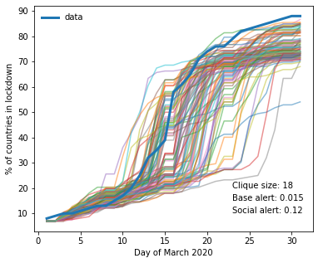

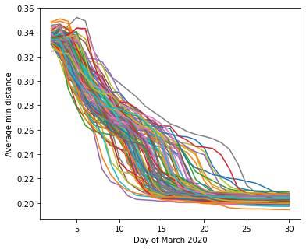

EXPERIMENT #5 18/08/2022

a.alert_adoption_threshold = (agent_data["log_population_density_normalized_on_average"][i])**2 * (1/agent_data["democracy_index_normalized_on_average"][i]) * base_alert

#### but the more democratic a country, the more sensitive they are to the influence of others

a.social_adoption_threshold = (agent_data["democracy_index_normalized_on_average"][i]) * social_base_threshold

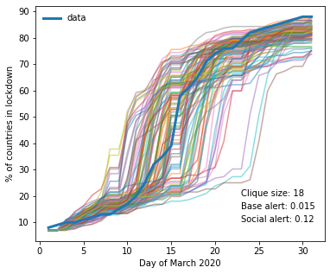

EXPERIMENT #6 19/08/2022

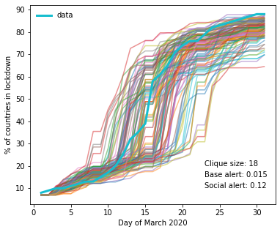

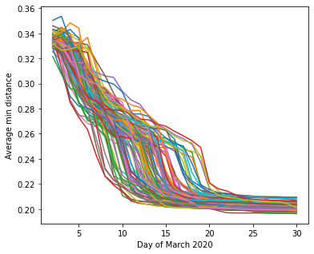

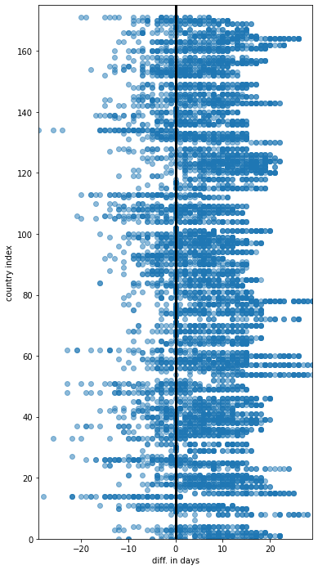

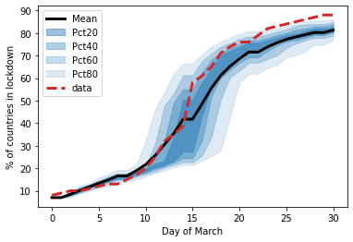

N = 109

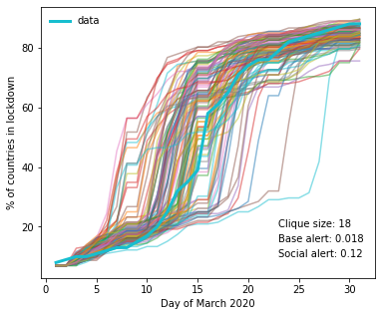

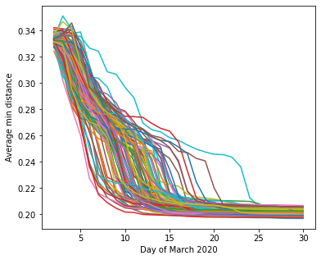

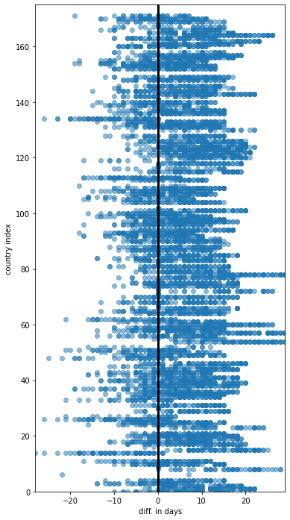

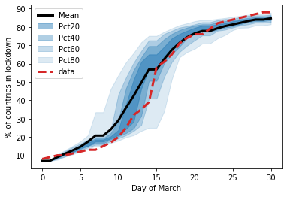

EXPERIMENT #7 19/08/2022

Question is

With “global” level mechanism . Yes because overall system state ( the number of lockdowned acountries) influences agent level variable. On the other hand one can easily imagine (and in fact they do anyway already) that countries count the other lockdowned countries.

In def step() in agent class

self.social_adoption_threshold = self.social_adoption_threshold + 0.000015*np.exp(0.04*len(list_of_lockdown_countries))

a*e^(b*number_of_countries)

N = 100

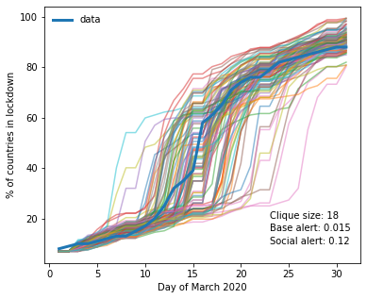

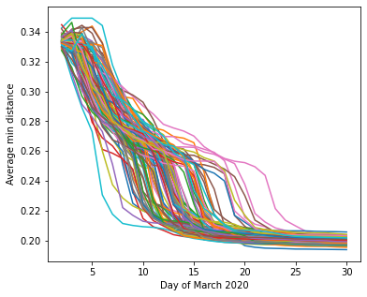

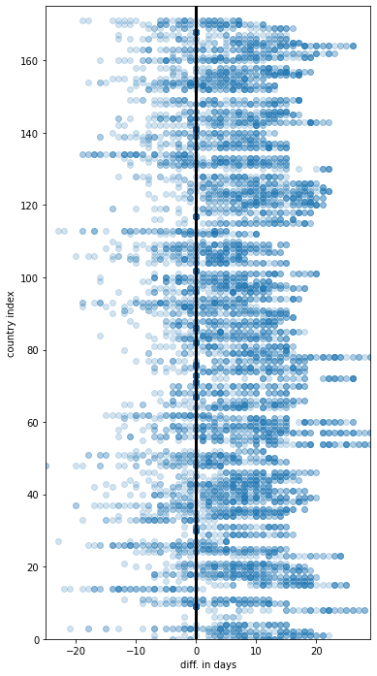

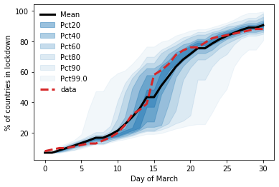

Experiment #8 22/08/2022

0 countries have adopted as initial conditions

N = 100

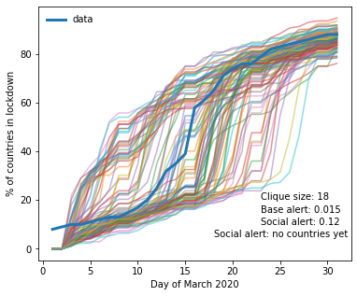

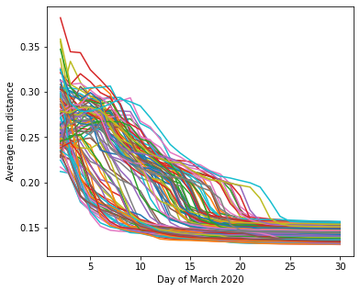

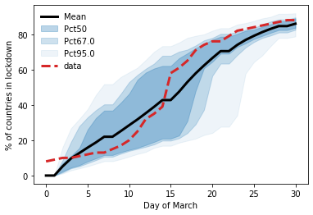

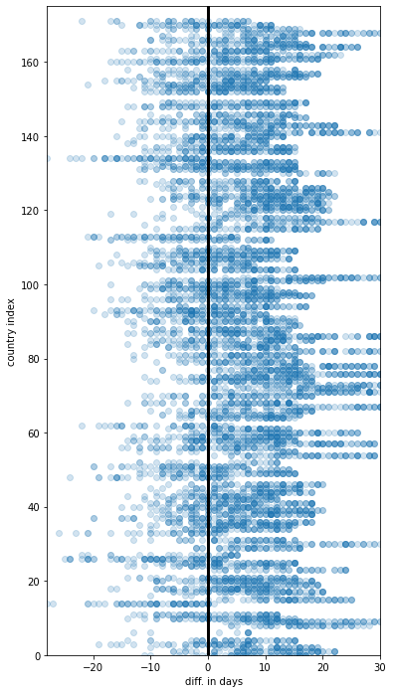

Experiment #9 22/08/2022

And importantly random initial conditions but with fixed density 0.07

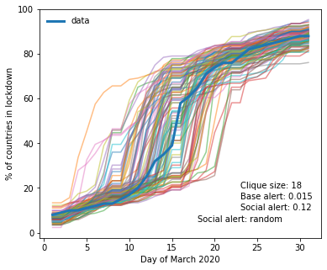

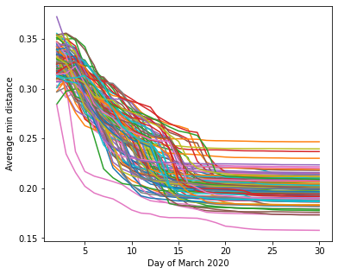

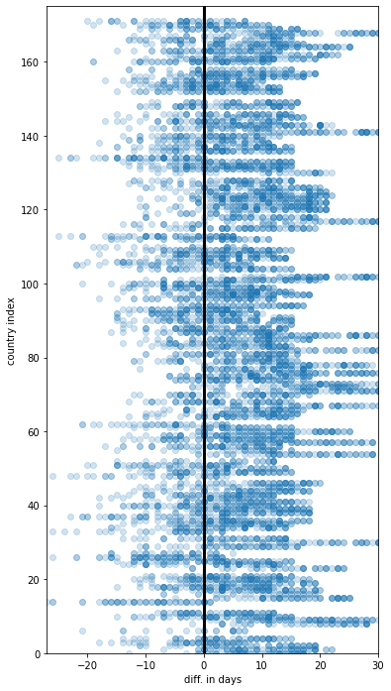

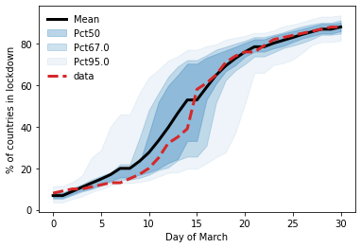

Experiment #10 26.08.2022

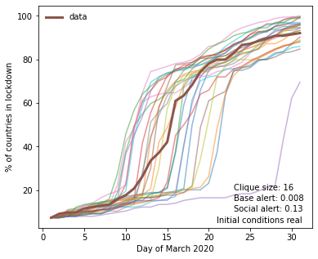

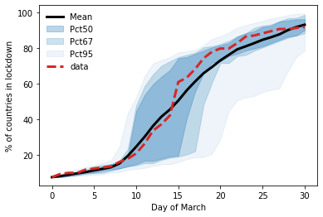

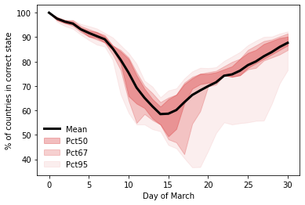

Experiment #11 26.08.2022

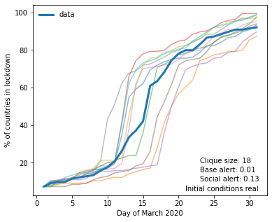

self.alert_adoption_threshold = self.alert_adoption_threshold + (self.alert_adoption_threshold + 0.00003*np.exp(0.044*len(list_of_lockdown_countries)) - self.alert_adoption_threshold)

Experiment #12 26.08.2022

Parameter self.data_update == "yes"

With direct data updates here after 15 steps in the middle, the model is corrected to the exact actual state. From then on however, it does not do a good job of predicting the actual curve. Even though before the mean was surpisingly correct.

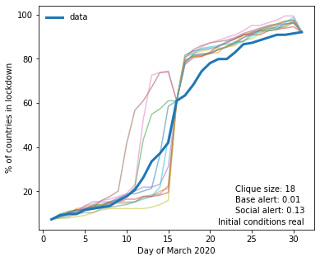

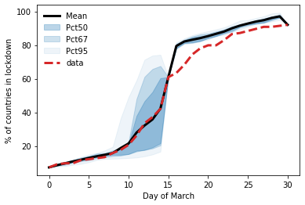

Experiment #13 PARTICLE FILTER ONE 12.10.2022

No of particles = 10, weird behaviour or working data assimilation?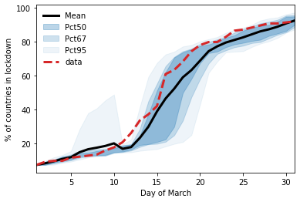

No of particles = 100 not sure variance reduction as good as hoped for, perhaps need to change/improve error metric

